PIZZA SALES REPORT
Project Goal: Understand pizza sales patterns, peak times, best/worst performers, and category/size contribution to help the restaurant optimise operations, inventory, and promotions.
Tools Used
- SQL Server – all analysis & KPI calculations
- Power BI – interactive dashboard with slicers and date filter
Dataset Pizza sales records (January–December 2015) Key fields: order_id, order_date, pizza_category, pizza_size, pizza_name, quantity, unit_price, total_price
What I Did
- Loaded data into SQL Server table: dbo.pizza_sales
- Wrote SQL queries for all KPIs, trends, and rankings
- Built Power BI dashboard with:
  - KPI cards
  - Daily & monthly trend charts
  - Category & size share visuals
  - Best/worst sellers bar
  - Date range slicer (Jan 2015 – Dec 2015)
  - Category slicer
Dashboard Highlights
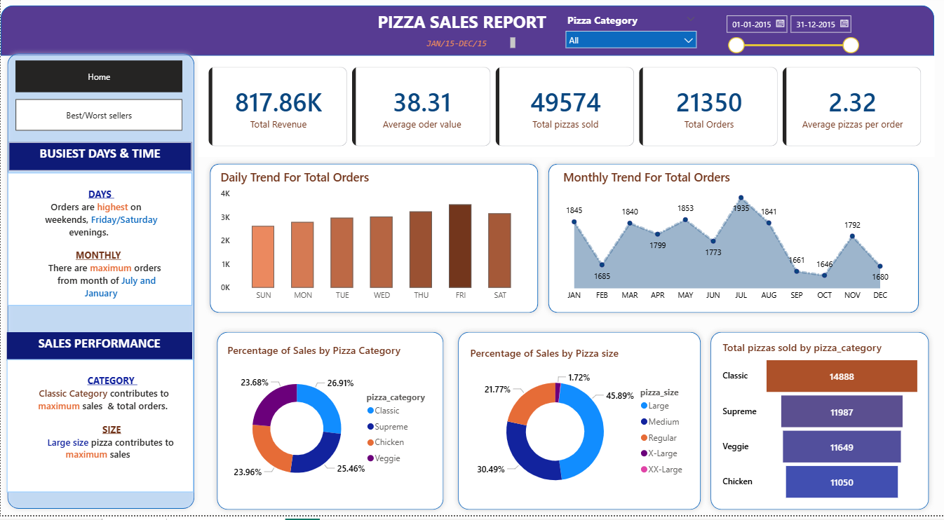
- Title: PIZZA SALES REPORT (purple header)
- Top KPIs (cards):
  - Total Revenue: $817.86K
  - Average Order Value: $38.31
  - Total Pizzas Sold: 49,574
  - Total Orders: 21,350
  - Average Pizzas per Order: 2.32
- Busiest Days & Time section:
  - Daily Trend for Total Orders → Highest on weekends (Friday & Saturday evenings peak)
  - Monthly Trend for Total Orders → Highest in July, January, and March
- Sales Performance section:
  - Percentage of Sales by Pizza Category → Classic leads (~26.91%)
  - Percentage of Sales by Pizza Size → Large dominates (~45.89%)
  - Total Pizzas Sold by Category → Classic highest (14,888), followed by Supreme (11,987) and Veggie (11,649)
- Slicers: Pizza Category dropdown + Date range slider (full year 2015)
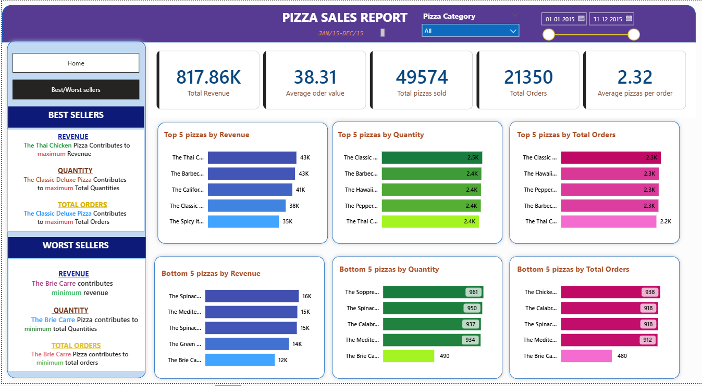
Key Insights
- Classic category contributes the most to total sales and orders.
- Large size pizzas are the most popular (almost 46% of sales).
- Orders are highest on weekends (Friday & Saturday) and in the evenings.
- Busiest months are July, January, and March — plan staffing and inventory accordingly.
- Top 5 best sellers generate significantly more revenue than bottom 5 → focus promotions on high performers.
SQL Queries Summary Calculated all dashboard numbers directly in SQL:
- Total Revenue, Average Order Value, Total Pizzas Sold, Total Orders, Avg Pizzas per Order
- Daily trend (by weekday)
- Monthly trend
- % Sales by Category
- % Sales by Size
- Top 5 & Bottom 5 best sellers by revenue
Recommendations
- Promote Classic and Large pizzas more (they drive most volume).
- Staff more on Friday & Saturday evenings and during July/January peaks.
- Analyze bottom 5 sellers — consider removing or revamping low performers.
- Offer combo deals on medium/large sizes to increase average order value.

